Nepal Tour for - 05 Nights 06 Days

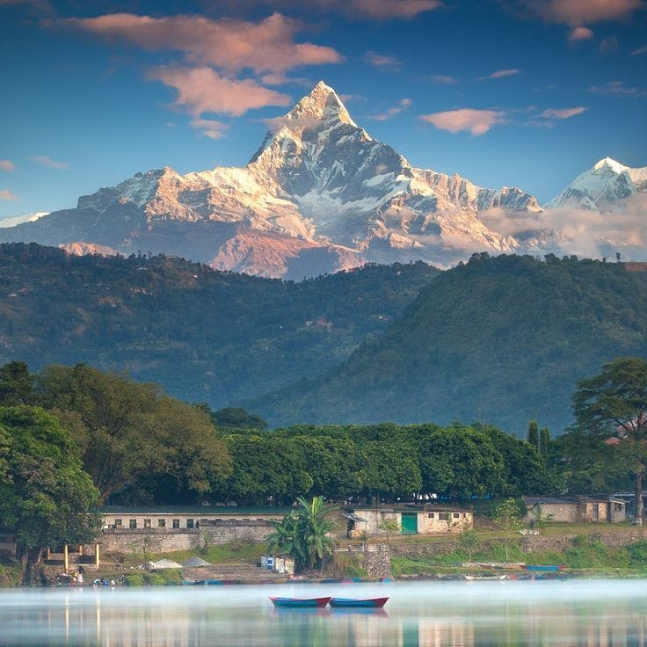​
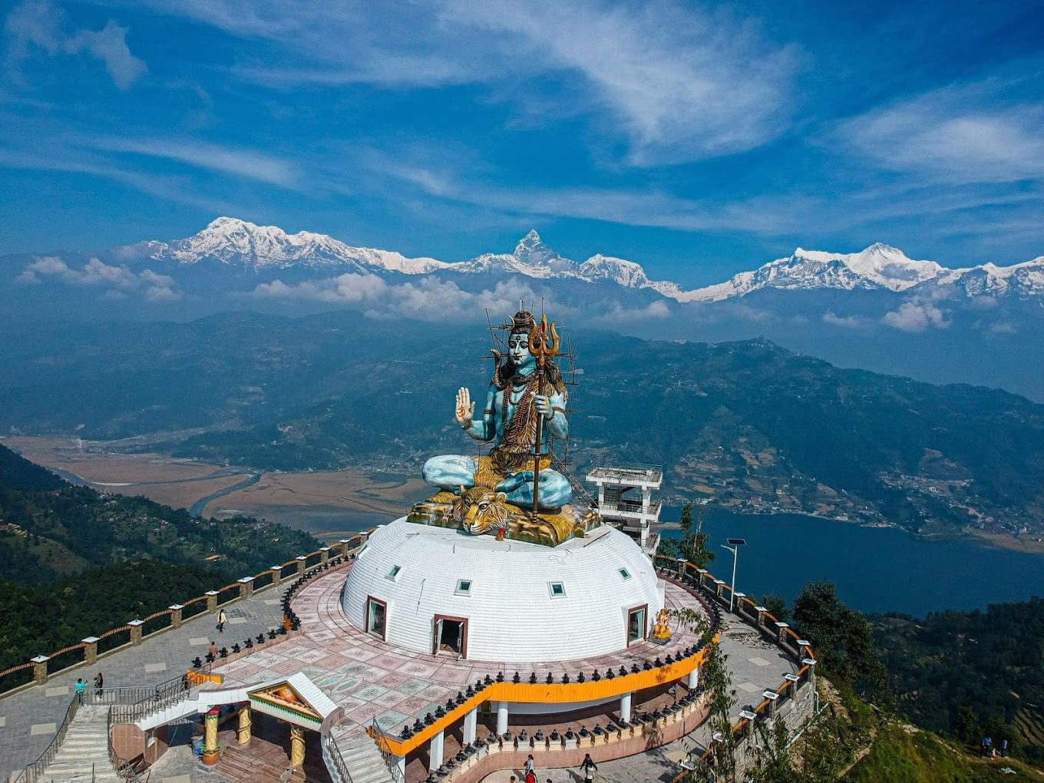

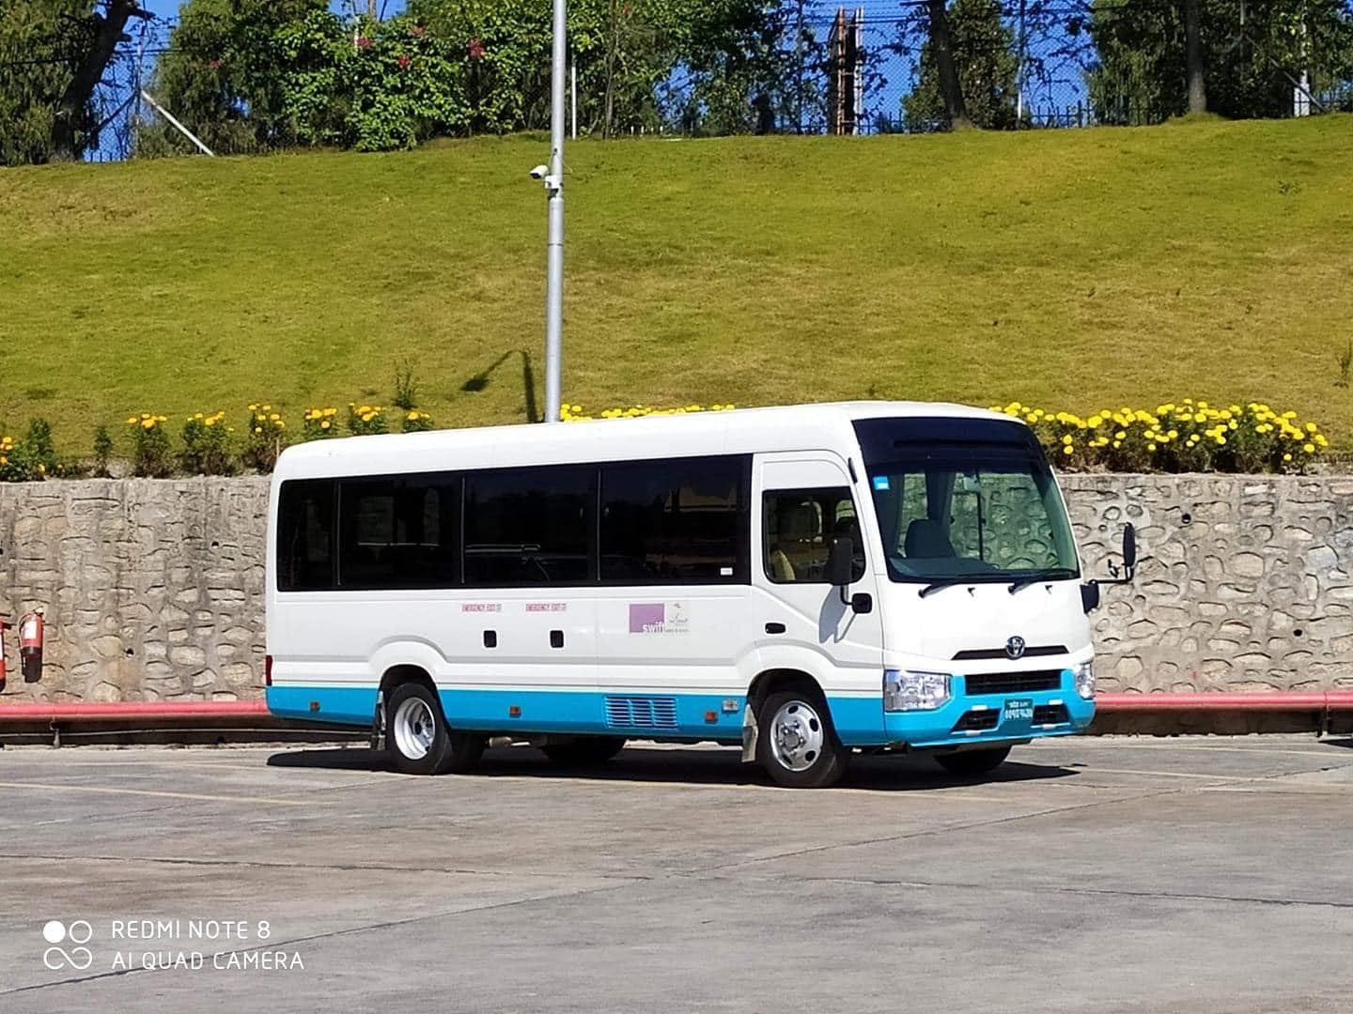
06 DAYS NEPAL TOUR PACKAGE
Kathmandu | Pokhara

Overview
Explore the spiritual and scenic beauty of Nepal with this 6-day tour covering Kathmandu and Pokhara. From sacred temples and UNESCO heritage sites to breathtaking Himalayan views and serene lakes, this journey offers a perfect blend of culture, nature, and relaxation for group travelers.

Tour Highlights
- Pashupatinath Temple Aarti experience
- Kathmandu UNESCO Heritage sightseeing
- Manakamana Temple Cable Car ride (enroute)
- Pokhara sunrise view from Pumdikot Shiva Temple
- Davis Falls & Gupteshwar Cave
- Phewa Lake boating & Tal Barahi Temple
- Scenic Himalayan views (weather permitting)
- Thamel market shopping experience

Hotel details
• 4-Star Option:
- Kathmandu: Hotel Akama by Ramada Encore – 03 Nights
- Pokhara: Hotel Atithi Resort – 02 Nights
Day-wise Itinerary
Day 01: Arrival in Kathmandu
Upon arrival at Kathmandu Airport, meet and greet by our representative and transfer to hotel for check-in. In the evening, visit Pashupatinath Temple to attend the sacred Aarti. Return to hotel. Overnight stay in Kathmandu.
Day 02: Kathmandu City Sightseeing
After breakfast, proceed for full-day sightseeing covering Boudhanath Stupa, Jal Narayan Temple (Sleeping Vishnu), Swayambhunath Stupa (Monkey Temple) and Kathmandu Durbar Square. Return to hotel. Overnight stay in Kathmandu.
Day 03: Kathmandu – Pokhara (via Manakamana)
After breakfast, drive to Pokhara (approx. 8–9 hrs). Enroute visit Manakamana Temple via cable car. Continue drive to Pokhara and check-in at hotel. In the evening, visit Tal Barahi Temple for Aarti. Overnight stay in Pokhara.
Day 04: Pokhara Sightseeing & Sunrise Tour
Early morning visit Pumdikot Shiva Temple to witness sunrise and panoramic mountain views (subject to weather). Later visit Davis Falls, Gupteshwar Mahadev Cave, Bindabasini Temple and Seti River Gorge. Enjoy one-hour boat ride on Phewa Lake and visit Tal Barahi Temple. Overnight stay in Pokhara.
Day 05: Pokhara – Kathmandu
After breakfast, drive back to Kathmandu. Upon arrival, check-in at hotel. Evening free for shopping at Thamel market. Overnight stay in Kathmandu.
Day 06: Departure
After breakfast, transfer to airport for onward journey.

Cost
4★ Premium Hotels: ₹ 24,450 per person (20 Pax – Double Sharing)

Trip Cost Breakdown (20–25 Pax)
- Hotels (Kathmandu & Pokhara)
- Meals (Breakfast, Lunch & Dinner)
- Transportation (Private A/C vehicle)
- Sightseeing & guide

Inclusions
- 03 nights accommodation in Kathmandu
- 02 nights accommodation in Pokhara
- Daily breakfast, lunch & dinner (AP Plan)
- Airport transfers & assistance
- Private A/C vehicle for entire tour
- Kathmandu & Pokhara sightseeing
- English/Hindi speaking guide
- 1 litre water bottle per day
- All applicable Nepal taxes

Exclusions
- International airfare
- Travel insurance
- Entry tickets to monuments
- Manakamana cable car tickets
- Boating charges at Phewa Lake
- Adventure activities in Pokhara
- Personal expenses (laundry, tips, etc.)
- Any services not mentioned in inclusions

Note: Cost may vary as per the ROE rates at the date of confirmation
Happy Journey……………………………………………………………………………………


